**Product Document**



**Team: TP31**

Table of contents

**1.Overview** **3**

1.0 WaterWhiz Platform Overview 3

1.1 Background 3

Problem Statement 3

Project Purpose 3

Target Audience 3

1.2 Product 4

1.21 Main Functions 4

1. Interactive stormwater impact maps 4

2. Household Stormwater Footprint Calculator 4

3. Water quality trends and forecasts 4

4. AI water quality question and answer assistant 4

5. Outdoor water activity planning tool 4

6. Priority catchment area display 5

7. Educational resources and best practices 5

1.22 Personalized Recommendations and Filtering 5

1.23 User Engagement and Community Interaction 5

1.24 Further exploration and support 5

**2.Ethic Canvas** **6**

2.1 Ethical Commitment Aligned with ACS Code of Conduct 6

2.1 Details of the ethical canvas 6

**3. Maintenance** **7**

**4. Future sponsor** **7**

4.1 Victorian Government departments 7

4.2 Environmental organizations and non-governmental organizations (NGOs) 7

4.3 Tertiary Education Institutions 7

4.4 Community and Local Organizations 8

4.5 Real Estate and Urban Planning Firms 8

**5. Future Plan** **8**

**6. Team information** **8**

# 1.Overview

## 1.0 WaterWhiz Platform Overview

The WaterWhiz platform is a comprehensive solution designed to address the complex challenges faced by Victorian residents and communities in stormwater management and water quality protection. This innovative platform not only provides users with critical information about stormwater pollution and its impacts, but also empowers them with the tools and knowledge to reduce their stormwater footprint, actively participate in community water quality protection initiatives, and create cleaner, healthier living environments.

## 1.1 Background

### **Problem Statement**

The degradation of water quality in Victoria’s creeks and rivers, driven by stormwater runoff—which accounts for 37% of the pollution—is increasingly troubling for environmentally conscious individuals aged 30 to 35 who are building their families and are passionate about water and outdoor activities. Despite government efforts to enhance stormwater infrastructure, urbanisation continues to introduce pollutants into waterways, endangering local ecosystems and the well-being of these active individuals. They are becoming more concerned about the health risks of spending time in polluted waters. How can we promote sustainable practices and empower these individuals to reduce pollution while safely enjoying their outdoor lifestyle?

### **Project Purpose**

The WaterWhiz project leverages open data to create tools and resources that assist Victorian residents in reducing stormwater pollution from their homes and in their community. By providing actionable insights and strategies, and educational resources, the project aims to support decision-makers in making informed choices about water pollution. WaterWhiz aspires to position Victoria as a leader in sustainable water management, where residents can achieve a balance between their environmental conscious and busy lifestyles.

### **Target Audience**

The target audience for the WaterWhiz project comprises Victorian residents, particularly those between the age 30 - 40 years, pursuing an IT career, outdoorsy and looking to spend a lot of time with their family by Victorian waters. These residents are motivated by environmental concerns but are also conscious of the impact of these sustainable practices. The project is designed for individuals who seek practical solutions to become aware and to reduce their water footprint while contributing to the preservation of Victoria's water resources.

## 1.2 Product

### **1.21 Main Functions**

#### **1. Interactive stormwater impact maps**

One of WaterWhiz's core features is its intuitive, interactive map interface, which allows users to view stormwater pollution and priority catchments across Victoria. Through color coding and detailed indicators, users can visualize the status of stormwater management in different areas, identify areas of priority concern, and understand where their community fits into overall water quality protection.

#### **2. Household Stormwater Footprint Calculator**

The platform provides an easy-to-use household stormwater footprint calculator to help users assess their household's contribution to stormwater runoff. Users can enter a variety of household-related data, such as yard size, percentage of paving, cleaning supplies used, etc. The results of the calculator will show the specific impacts of household activities on local water quality and provide personalized recommendations for reducing emissions.

#### **3. Water quality trends and forecasts**

Based on Victoria's water quality observations over the past decade, WaterWhiz utilizes advanced algorithms to predict changes in water quality over the next six months. Users can view historical trends and future forecasts for different water quality monitoring sites, helping them make more informed decisions when choosing where to live or planning outdoor activities.

#### **4. AI water quality question and answer assistant**

WaterWhiz integrates an intelligent Q&A assistant that allows users to ask and answer up to five questions on the same page without registration. The assistant is able to provide detailed water quality information based on the user's location, generate routes out of the house with high quality water according to the user's needs, recommend a list of necessary items, etc., to enhance the user's experience and interactivity.

#### **5. Outdoor water activity planning tool**

To help users plan outdoor water activities safely and responsibly, WaterWhiz provides an interactive map showing the location of water bodies across Victoria. Users can select their preferred type of activity (especially swimming) and view the current pollution levels of the selected stream and its safety implications for the activity, ensuring the health and safety of the user and their family.

#### **6. Priority catchment area display**

The platform displays Victoria's priority catchment areas through an interactive color map to help users understand which areas need more attention in terms of stormwater management. Users can click on a specific sub-catchment to view detailed indicator data such as rainwater harvesting rate, infiltration rate, etc. to gain insight into the current status of stormwater management and improvement measures in that area.

#### **7. Educational resources and best practices**

WaterWhiz provides a detailed knowledge center covering sources of stormwater, the impacts of stormwater pollution, and their solutions. Users can browse stormwater management best practices for homes, streets, gardens, and vehicles, and get practical implementation guides and compliance information to help them effectively reduce stormwater pollution in their daily lives.

### **1.22 Personalized Recommendations and Filtering**

WaterWhiz allows users to filter and customize the information they need based on their personal preferences. For example, users can choose to view water quality data only for a specific area or filter content based on specific stormwater management practices. Additionally, the platform provides personalized community engagement recommendations and priority action areas based on user habits and data input, simplifying the decision-making process and increasing user engagement.

### **1.23 User Engagement and Community Interaction**

WaterWhiz encourages users to actively participate in community water quality initiatives. The platform provides a reporting feature that allows users to report pollution incidents or unsafe water quality conditions, and promotes community participation in maintaining the water environment. In addition, users can participate in local stormwater management programs and volunteer activities through the platform, enhancing community cohesion and promoting sustainable development.

### **1.24 Further exploration and support**

For detailed inspection on the product, refer to [Website link](https://waterwhiz.site/#/home).

You can refer to the [Mahara](https://mahara.infotech.monash.edu/view/view.php?t=U8cCZexApMwvigO9rokT) which includes product video to understand more on WaterWhiz’s epics and features.

# 2.Ethic Canvas

## 2.1 Ethical Commitment Aligned with ACS Code of Conduct

WaterWhiz's ethical canvas comprehensively covers the key areas of data privacy, security, transparency, fairness, environmental responsibility and user trust. By strictly adhering to the ACS Code of Conduct and adopting specific responses, we ensure that our platform delivers superior functionality while always adhering to the highest ethical standards. Always demonstrating integrity, honesty and responsibility in our product development and operations, we are committed to finding a balance between technological advancement and ethical responsibility to ensure that the platform is not only functionally superior, but also ethically trustworthy.WaterWhiz is committed to advancing the cause of water quality protection in Victoria through the marriage of technology and ethics to promote sustainable communities and healthy living.

## 2.1 Details of the ethical canvas

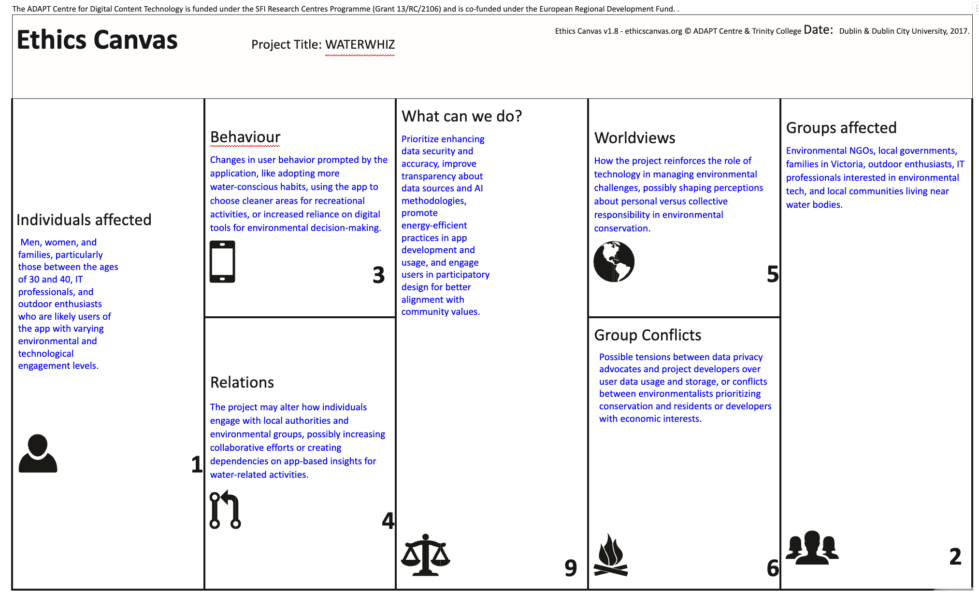

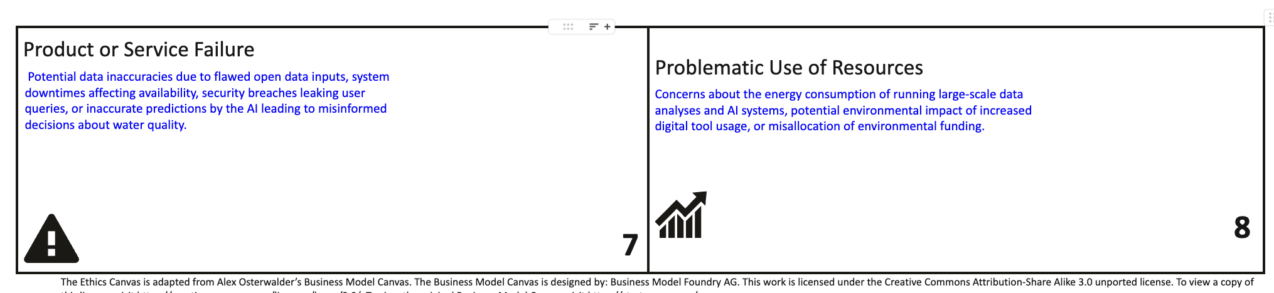

# 3. Maintenance

To ensure the stable operation and continuous improvement of the WaterWhiz platform, our team has developed detailed [System Architecture Design](https://docs.google.com/document/d/1McNYUa9-cqwolaxH-h-tMUQ0plqE7qLZFMWK-ObQmls/edit?usp=drive_link), [support document](https://docs.google.com/document/d/1G0vgmTblbaqmItzq1pXb3E2fdk_qsx2bmFWTekLJKQs/edit?usp=drive_link) and [maintenance document](https://docs.google.com/document/d/1n1Q07v7YDNqvJ_k_B5gwlyoAb8UWFG4BtlzgbP2rlJ4/edit?usp=drive_link). These documents cover server setup, security maintenance, and dataset management for building and optimizing the platform throughout the development and iteration cycles. On the operational side, we have additional backend and [data governance](https://drive.google.com/file/d/1TDu7JxFPIY13XwaKWl-Ypd1vwURXqFLW/view?usp=sharing) mechanisms to handle data deployment and maintenance. In terms of safety, please review our [⁠Security Plan](https://docs.google.com/document/d/1lEqQMPkpflMvhbhQlKfPQylViXtsUL0f/edit?usp=drive_link&ouid=109287407376442581056&rtpof=true&sd=true), [Cyber Security Report——Iteration 2](https://docs.google.com/document/d/1aQUHiFbDr7PB_QgQ0mjIB_Tb_PBWuyx-/edit?usp=drive_link&ouid=109287407376442581056&rtpof=true&sd=true) and [Cyber Security Report——Iteration 3](https://docs.google.com/document/d/1RcsSukDO1ri7nMItYLDXgLu-lmY4mh17/edit?usp=drive_link&ouid=109287407376442581056&rtpof=true&sd=true).

# 4. Future sponsor

The WaterWhiz platform is designed to support Victoria's sustainability goals through advanced stormwater management and water quality protection solutions. Not only is our platform highly aligned with the environmental mission of government agencies, but it also provides valuable tools and data support for educational institutions, community organizations, and business partners. Below are WaterWhiz's future sponsors and their potential partnership opportunities:

## 4.1 Victorian Government departments

The Victorian Government's Environmental Protection and Water Resources Management Departments are committed to improving water quality and managing stormwater runoff, and the WaterWhiz platform provides them with detailed water quality data analysis, predictive modeling, and community engagement tools to help them develop more effective policies and measures to optimize stormwater management systems and improve the overall quality of the water environment.

## 4.2 Environmental organizations and non-governmental organizations (NGOs)

In partnership with local and national environmental organizations, such as EPA Victoria and Friends of the Earth, WaterWhiz can work together on water quality protection campaigns, drive community engagement, and leverage the platform's data and tools to raise public awareness and action on stormwater pollution.

## 4.3 Tertiary Education Institutions

WaterWhiz can work with Victorian universities and research institutions such as the University of Melbourne and Monash University to support their environmental science and urban planning research programs. By providing real-time water quality data and predictive analytics, researchers are able to conduct in-depth water environment studies, drive innovative stormwater management solutions, and provide students with practical learning and research tools.

## 4.4 Community and Local Organizations

WaterWhiz is committed to fostering community action for water quality protection by partnering with local community organizations and volunteer groups to promote resident participation in stormwater management and water conservation projects. Community organizations can use the platform's tools and data to conduct educational campaigns, pollution monitoring, and environmental improvement projects to increase community cohesion and environmental awareness.

## 4.5 Real Estate and Urban Planning Firms

The WaterWhiz platform provides real estate developers and urban planning firms with critical water quality and stormwater management data to help them consider environmental impacts when planning new communities and developments. By integrating WaterWhiz's data analytics, real estate companies can optimize the sustainable design of their projects, increasing their environmental value and marketability.

# 5. Future Plan

For details on the future of water whiz, please refer to [Future Plan](https://docs.google.com/document/d/1ZLs6HaRKDt1WTppyZMgYmv9cDx0sdE30Su4kUokUE-I/edit?usp=sharing).

# 6. Team information

**Name: Sanchita Reddy**

Discipline: Master of Data Science

Email: [sred0013@student.monash.edu](mailto:sred0013@student.monash.edu)

Photo:



Description:

Hey there! I'm someone who thrives on the simple pleasures in life. Born and raised in India, I’m all about the thrill of smashing a badminton shuttle and catching the latest sports action. When I’m not on the court or glued to a game, you’ll find me whipping up something delicious in the kitchen.

I’m also a big fan of hitting the road—there’s nothing like a long, scenic drive to clear the mind. And when it’s time to relax, you can bet I’m curled up with a good book, losing track of time. Oh, and I can’t forget Zoe, my lovable Labrador back home, who’s always in my thoughts.

Life’s all about the little joys, and I’m here to soak them all in!

**Name:Jiaqi Zhang(Leslie)**

Discipline:Master of Information Technology

Email: jzha0455@student.monash.edu

Photo:

Description: Hi guys, I am from China. I have a complex personality and every MBTI test results are different, but overall I am a friendly, polite and helpful person. I love the NBA and enjoy going to concerts. Let's work together and get the HD!

**Name:Chuanqing Sun(Nick)**

Discipline: Master of Artificial Intelligence

Email: csun0046@student.monash.edu

Photo: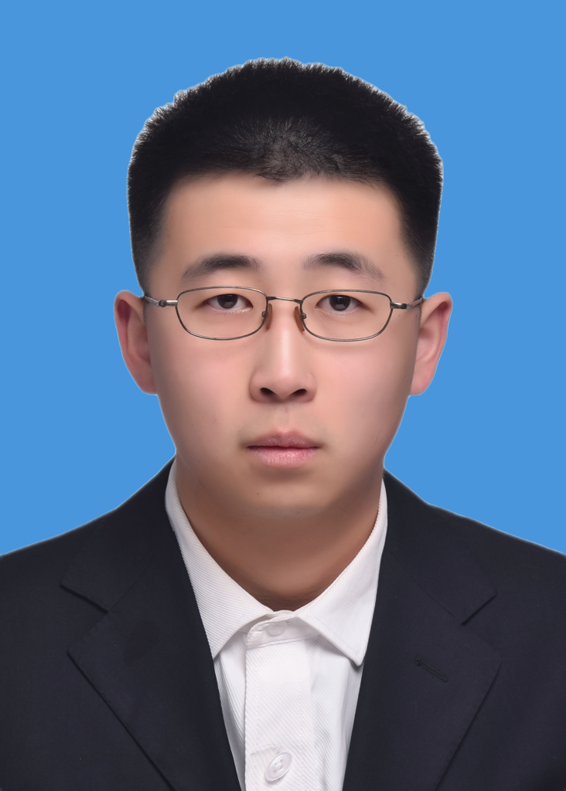

Description:

Hello everyone, I am from China. I like to study some very interesting things, for example, I like to explore some practical small technology very much. At the same time, I also pay much attention to and understand the technology products. I like playing badminton and running very much.

In my normal life, I would like to read some history books very much. Thinking about problems from their point of view often makes me enjoy very much.

**Name: Mingrui Ma (Mary)**

Discipline: Master of Business Information System

Email: mmaa0032@student.monash.edu

Photo:

Description: Hello everyone, nice to meet you all. I come from the north of China, where it snows every winter, so I think the temperature in Melbourne is really suitable for living! I like to eat hot pot and desserts that are not too sweet. When I have free time, I like to play mobile games such as Genshin Impact and zzz. Although I still look a little fat, I have actually lost 22 pounds in order to take beautiful photos with my dear teammates, and now I have a tendency to gain weight again (crying). I am very happy to be able to team up with such an excellent group of teammates. This is my luck.

**Name: Angad Virdi**

Discipline: Master of Data Science

Email: avir0007@student.monash.edu



Description: Hi folks!, I'm from India, belonging to the Sikh community. I’m really passionate about finance, especially crypto, and I think it would be great if we could make our final project about this. I know the staff suggested a topic for the public good, but with so many people getting scammed by meme coins, we could really help out by educating retail investors and saving them some money, which definitely counts as a public good! I also love history and enjoy giving historical anecdotes, especially when I can relate them to current events.